# Worksheet 7 – Composite Adjustments

The directory .\data\qss\ contains the four medical-related revenue series from the Quarterly Services Survey that date back to Q4 2004. In this exercise we adjust the total of these four series.

1. **Create individual spec files for the four series**
   1. In Win X-13, select the folder […]\data\qss. Then go to Create → Data metafile. In the window that appears, select  
       Hospitals – Tax-Exempt.dat  
       Hospitals – Taxable.dat  
       Nursing and Residential Care Facilities – Tax-Exempt.dat  
       Nursing and Residential Care Facilities – Taxable.dat  
      Name your new metafile **med** and press the button to *Create metafile*.

From the main Win X-13 screen, go to Create –>Spec file. In the *Data file or data metafile* box, enter […]**\data\qss\med.dta**.  
  
Set the *Period* to 4.  
  
In the *Prior Adjustments* tab, include a test for temporary change outliers in addition to the additive outliers and level shifts. Since we don’t expect identifiable trading day or Easter effects for these series, uncheck the boxes asking for those AIC tests.

The series will be added together to find the total, so in the *Seasonal Adjustment* tab, in the box asking how the series should be combined into the aggregate, select *Add series into the aggregate*.

To get history diagnostics for the indirect series, the history start date must be set in each component spec file. Set the history start date to 2013.1 in the *Seasonal Adjustment* tab.

Press the *Create Spec* button.  
  
Note that four new spec files were added to .\data\qss\.

1. **Create a spec file for the aggregate/parent spec**

From the main Win X-13 screen, go to Create -> Spec file.

In the *Data* tab, select the radio button to *Create a parent spec for a composite adjustment*. Save the new spec file as […]\data\qss\MedServices.spc.

Set the *Period* to 4.

In the *Prior Adjustments* tab, include a test for temporary change outliers. Uncheck the boxes for trading day and Easter tests.

In the *Seasonal Adjustment* tab, set the history start date to 2013. 1.

Press *Create spec.* Note that when creating composite specs, nothing gets hard-coded into the spec file.

1. **Create a metafile to run the composite**

From the main Win X-13 screen, go to Create -> Metafile.

In the box to the right, select all five of the spec files.

Name the new metafile **med**.

The box in the lower left asks if you are running a composite adjustment. Select Yes. In the box below, select **MedServices** as the parent file.

Press *Create metafile.*

The new metafile will appear. Note that MedServices is the last spec listed.

**Run the metafile med.mta.**

**Questions**

1. Look through the Diagnostics table for the four regional series. Which series does not appear seasonal?

Nursing and Residential Care Facilities – Taxable has a QS of the original series with p = 0.685. The X-11 seasonality diagnostics (D8F and M7) also indicate a lack of seasonality.

1. Open the spec file of the series you identified as not seasonal and edit it so that the original series rather than the seasonally adjusted series is added to the composite. Re-run med.mta.

We edit the Nursing and Residential Care Facilities – Taxable spec file so that the x11{} spec is x11{ type = trend }.

1. Is there residual seasonality in either the direct or the indirect adjustment?

The QS of the seasonally adjusted series and the irregular all have p = 1.00 for both the direct and the indirect adjustments, so we do not see evidence of residual seasonality.

1. Do all four component series have passing sliding spans diagnostics? Does the direct or the indirect adjustment show more stable sliding span results?

Because the seasonal factors for these series are so small, the percentage of failing quarters does not get calculated. However, we see that the SF75p and MM60p columns of the Stability Diagnostics tab have values below 0.46 and 0.64, respectively, for all series, so for all series 75% of quarters have a maximum percent difference of the seasonal factors less than 0.46 (or less, depending on the series) and 60% of quarter-to-quarter changes have an MPD below 0.64 (or less). A failing diagnostic would find these percentiles to be over 3.0.

The direct and indirect adjustment are very close in stability; the 75th percentile of maximum percent differences in the seasonal factors is 0.197 for the direct and 0.189 for the indirect, so the indirect is just barely more stable, but these numbers are too close to come to any conclusion. (Both adjustments are very stable.)

1. Average absolute percent revisions of the seasonal adjustments were produced for both the direct and the indirect adjustment. Which has a lower total revision?

The direct has SA.AAR of 0.156 and the indirect of 0.161. The direct is just a touch lower, but these numbers are too close to come to any conclusion.

1. Look at the seasonal factors by quarter graph for the three seasonal components using Win X-13 graphs or X-13-Graph. Does the seasonal pattern look similar for each series?

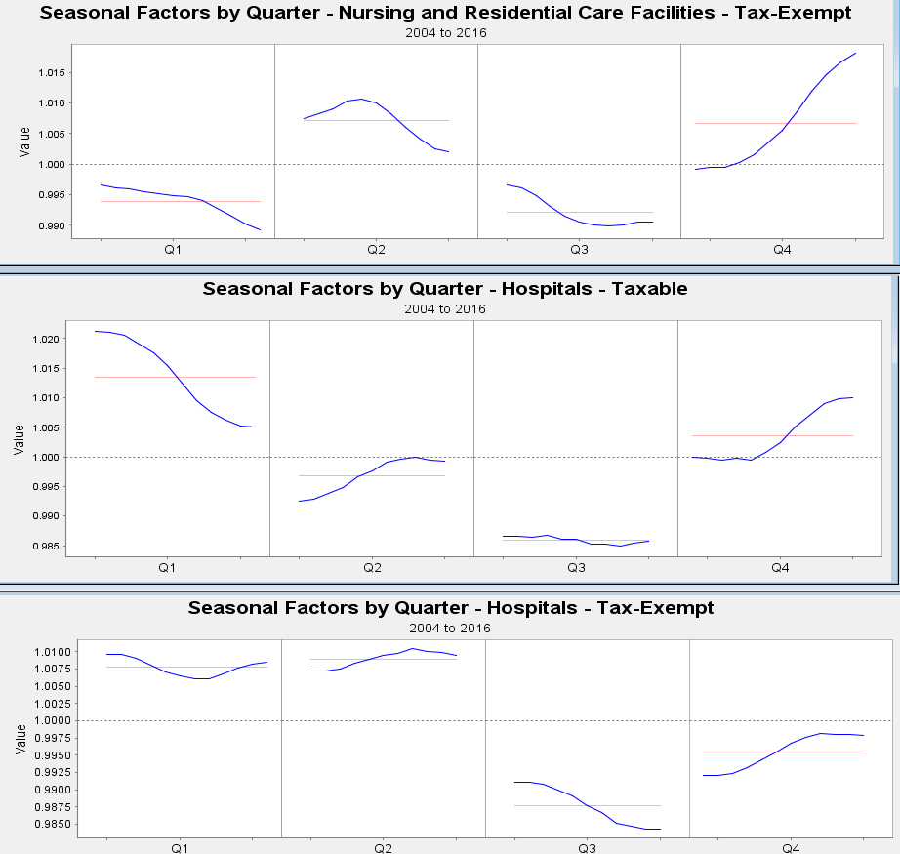

Q3 always has seasonal factors less than 1, but the other three quarters do not have any consistency.

1. Use X-13-Graph to create an overlay graph of the direct and indirect seasonal adjustments. Describe the graph.

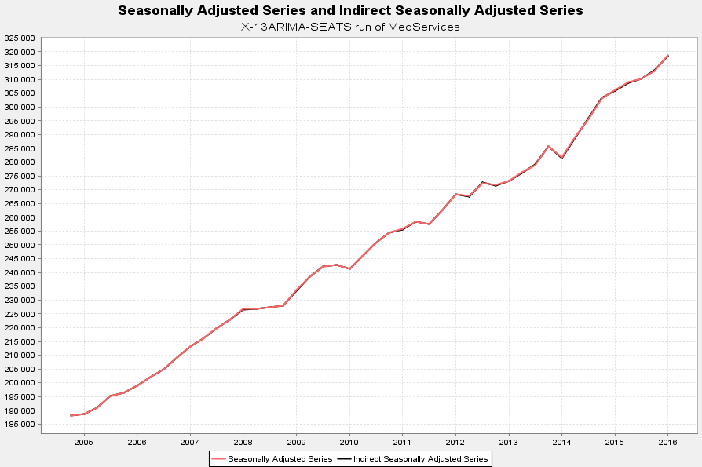

The direct and indirect adjustment are very similar.

1. Do you prefer the direct or the indirect seasonal adjustment?

Because the adjustments are so similar and the diagnostics are almost identical it does not seem to matter which one is selected. Your decision may instead be based on other aspects, like expectations of additivity or transparency of methods.